**AWS 101 EBS: Getting Started with .NET on Elastic Beanstalk**

*Posted On September 12, 2019*

The following task will help you to create, view, manage, create, deploy an application, create its instance alarm and edit and terminate your EBS environment.

**Login to AWS console**

For new user, sign up to [console.aws.amazon.com](http://console.aws.amazon.com/). If already having console account, you can access Elastic Beanstalk of Amazon Web Services for creating and managing various kinds of environment. Other services that will come and be useful with EBS would be Amazon Elastic Compute Cloud( for creating instances), Amazon Notification Services(Alarm) , Amazon S3( Object Storage Provider).

**Open Elastic Beanstalk Console and Create an Application**

**Open the**[**Elastic Beanstalk console**](https://console.aws.amazon.com/elasticbeanstalk). EBS is free to use but since the application goes live therefore , it incur standard charge unless you are using Free Tier (*conditions apply).

First, use the Create New Application wizard in the Elastic Beanstalk console to create the application environment. For **Platform**, choose **.NET**.

**To launch an environment (console)**

1. Open the Elastic Beanstalk console.
2. For **Platform**, choose the platform(.Net WindowsIIS) that matches the language used by your application.
3. For **Application code**, choose **Sample application** or Upload Successfully Built Application to avoid erroneous and thus failed deployment.
4. **Create app**

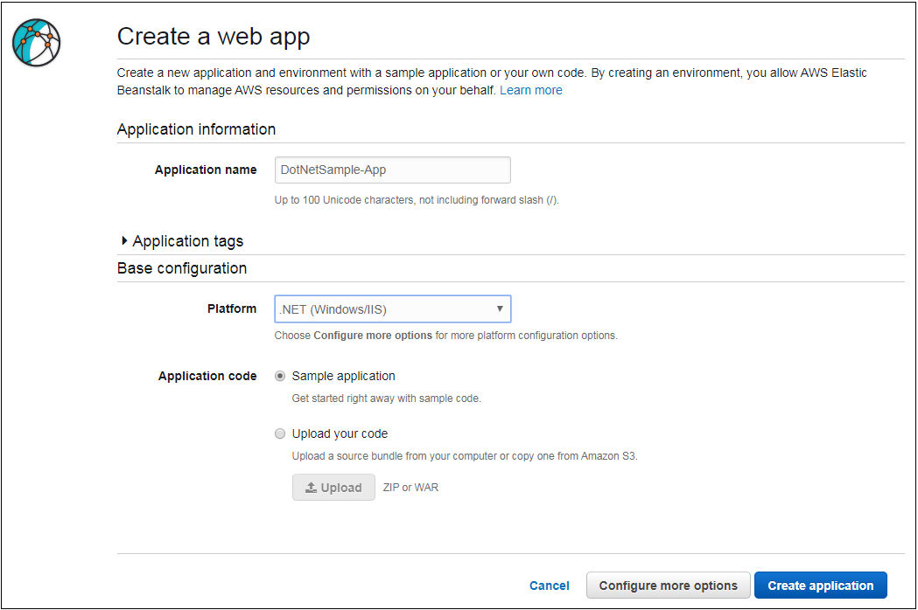

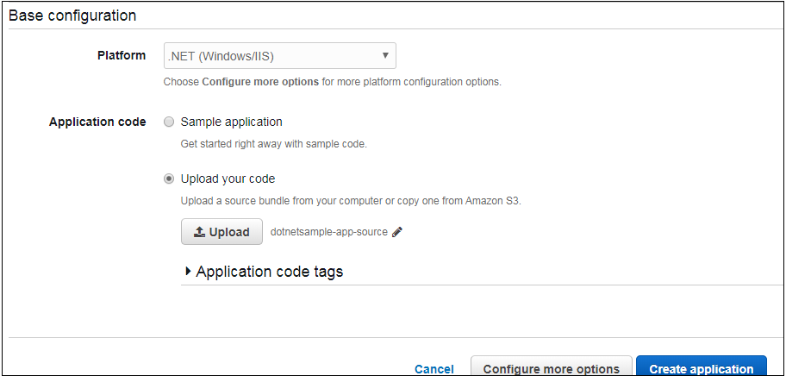

**Actions performed while creating EBS Application Environment**

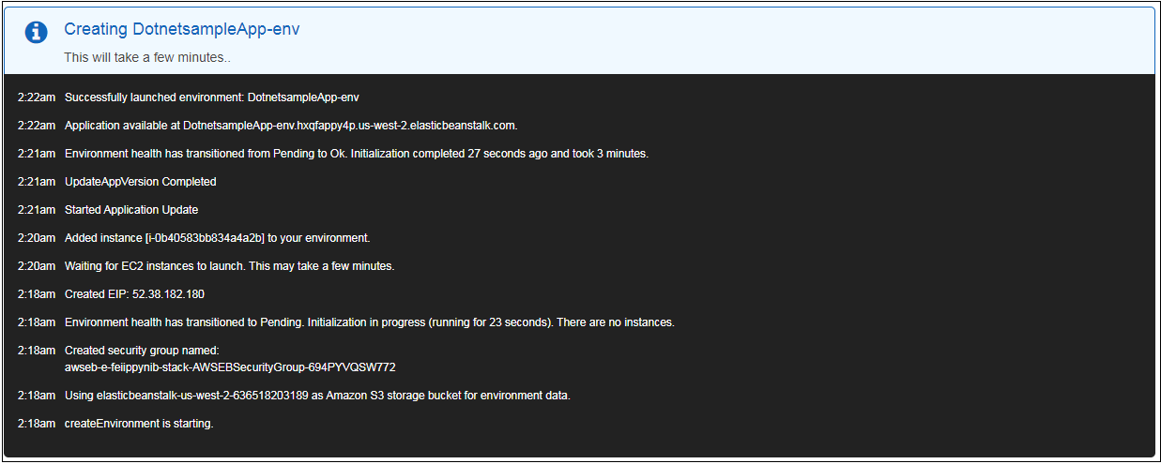

Explore the navigation pane to view the current status of your environment.

**Monitoring**helps shows CPU Utilization and the statistics can be used to create alarm for monitoring.

**Health** shows health information of EC2 instances running the application.

**Configuration** shows the resources being used/provisioned by application.

**Events** helps in getting error details or any information concerning application running status. In the event of any error occurance or to search for environment details, created Logs can be downloaded and searched. There are two types: 1. Last 100 lines and Full Logs.

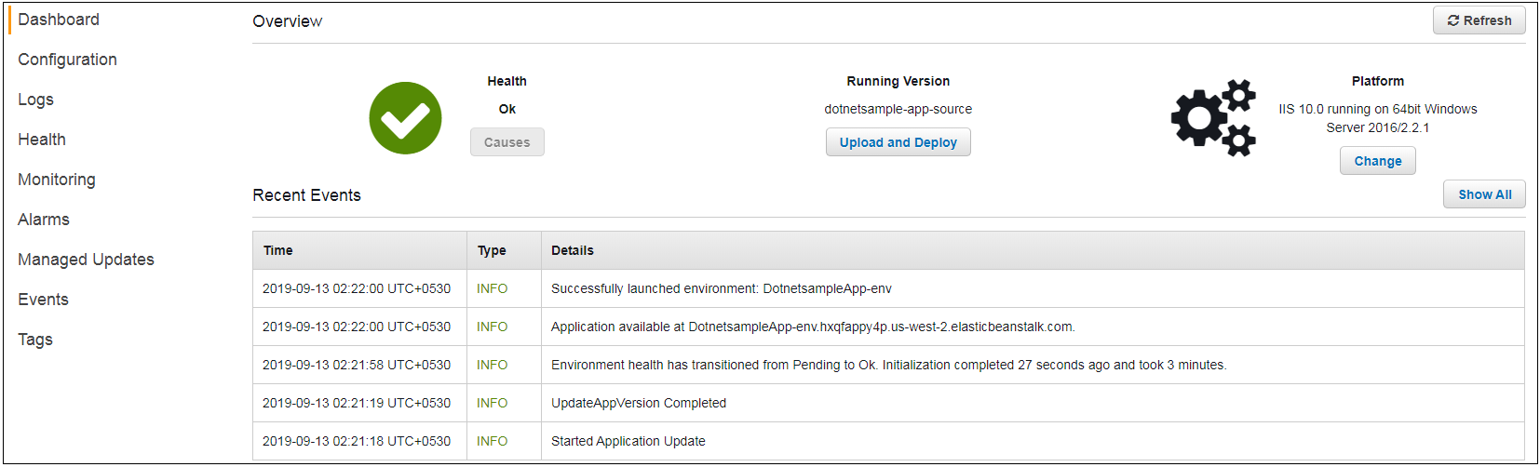

**View Environment Details from Dashboard**

After creating EBS application, you can view the application deployed by visting dashboard in the AWS Management Console.

It finally create application and its environment. Dashboard will look in Green denoting healthy status. Yellow shows warning. Event/s Red is severe and will need to be addressed.

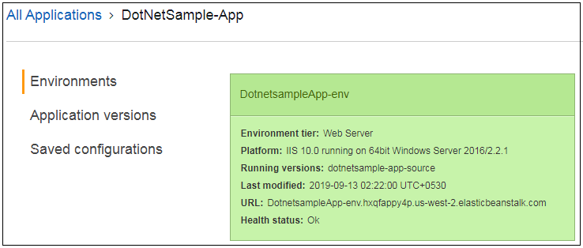

In the right hand corner, an Action tab appears with list of actions that can be performed like Loading and Saving Configuration, Restarting App Server, Rebuilt and Terminate Environment.

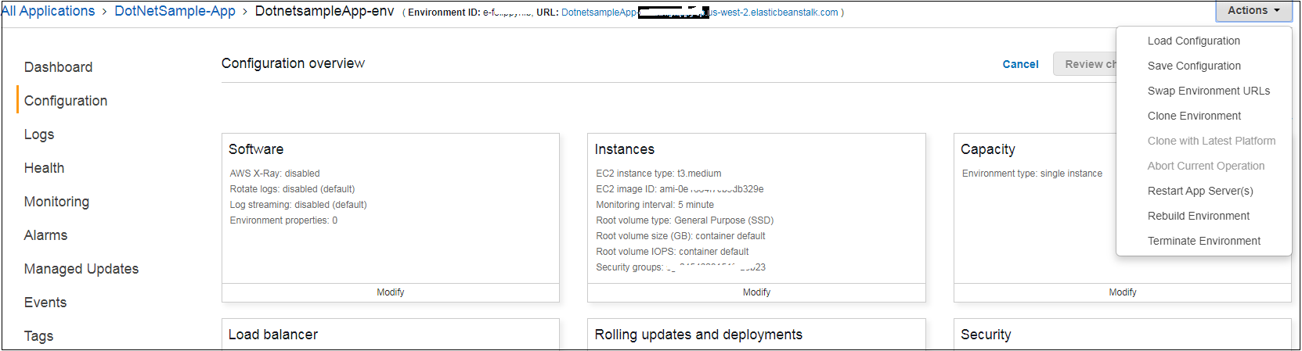

Clicking on the URL would open the Deployed App.

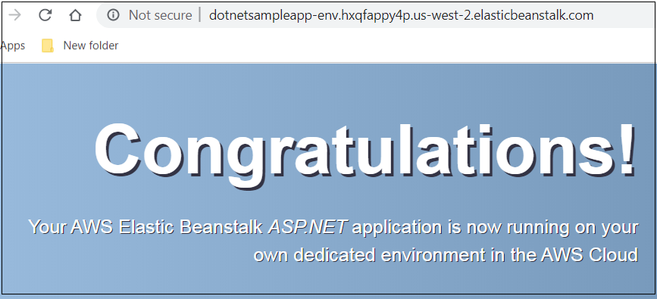

**To add a DB instance to your environment**

1. Open the [Elastic Beanstalk console](https://console.aws.amazon.com/elasticbeanstalk).
2. Navigate to the [management page](https://docs.aws.amazon.com/elasticbeanstalk/latest/dg/environments-console.html) for your environment located as ‘Manage Update’ in Dashboard Pane.
3. Choose **Configuration**.
4. In the **Database** configuration category, choose **Modify**.
5. Choose a DB engine, and enter a user name and password.
6. Choose **Apply**.

